Create database
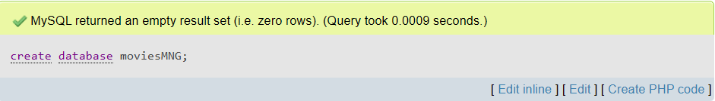
Consider the following
- Actor (aid, name, age, gender, salary)
- Movie (mid, title, budget)
- Plays (aid, mid)
Create table Actor
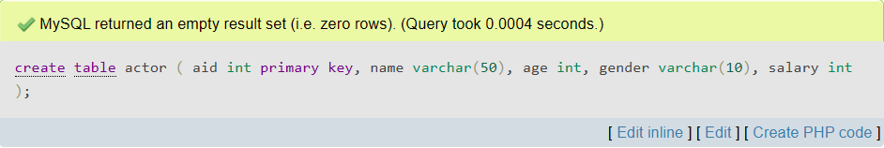
Create table Movie
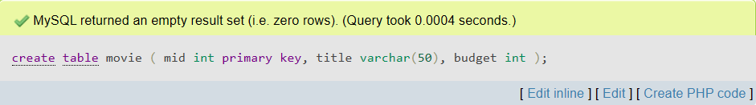
Create table Plays
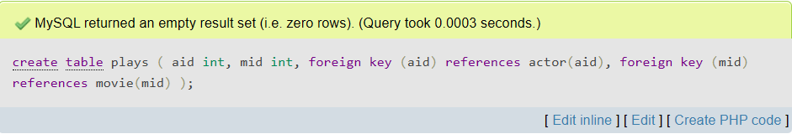

Describe Actor
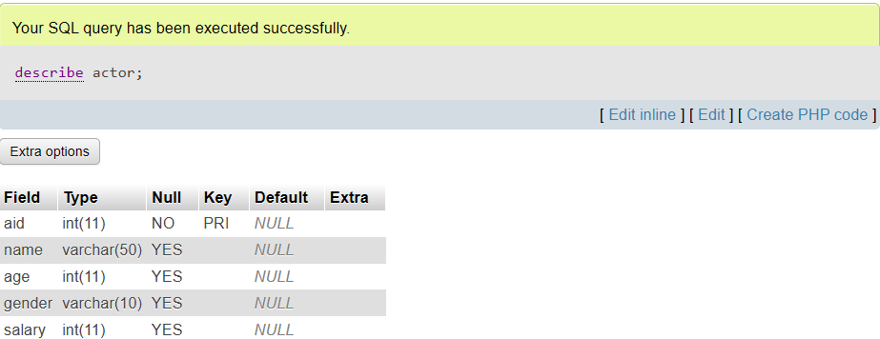
Insert Actor
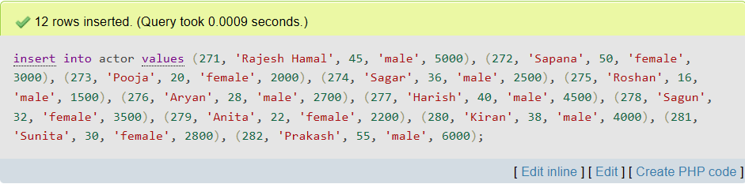
Display Actor
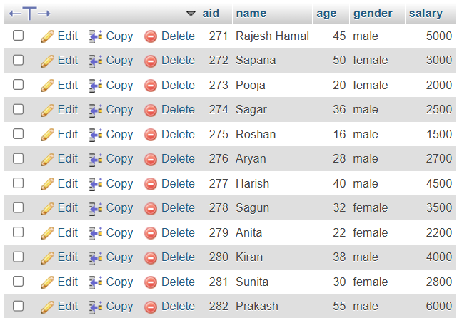
Describe Movie
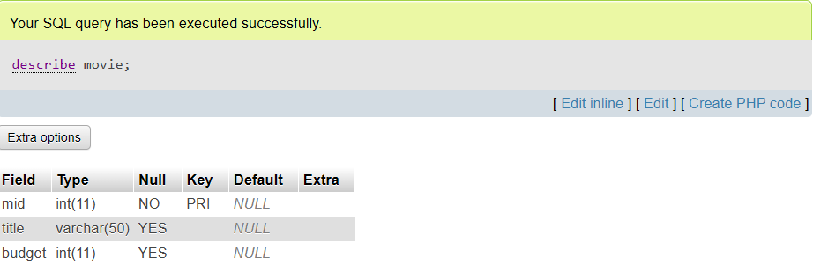
Insert Movie
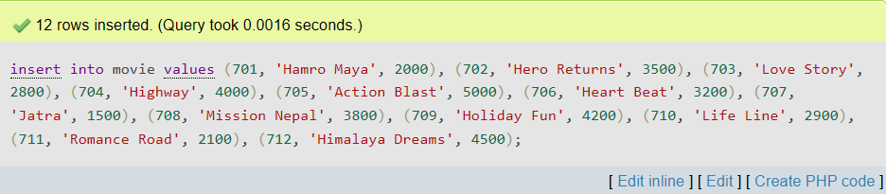
Display Movie
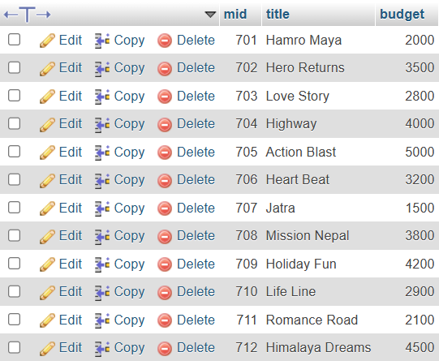
Describe Plays
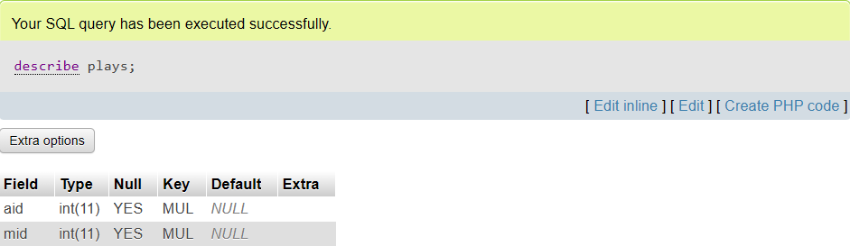
Insert Plays
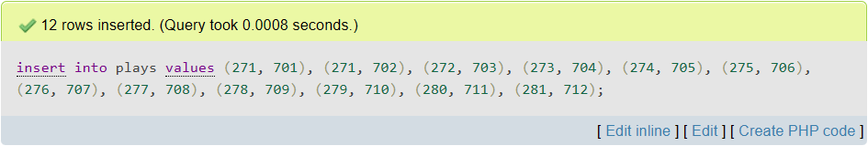
Display Plays
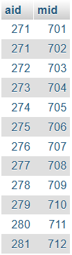

- Write SQL queries
- Display the name of female actor with minimum salary.
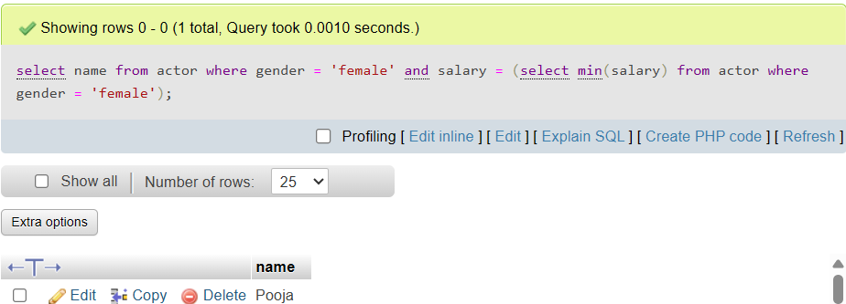
- Display the name of movies which name starts from “h”.
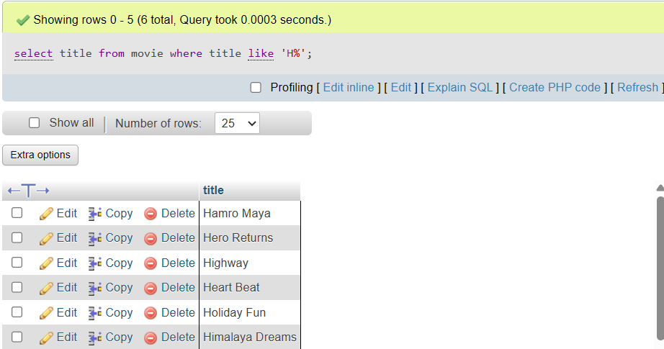
- Delete the record of actor whose age is less than 17.
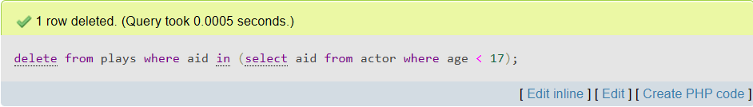

- Display movie id of all movies played by “Rajesh Hamal”.
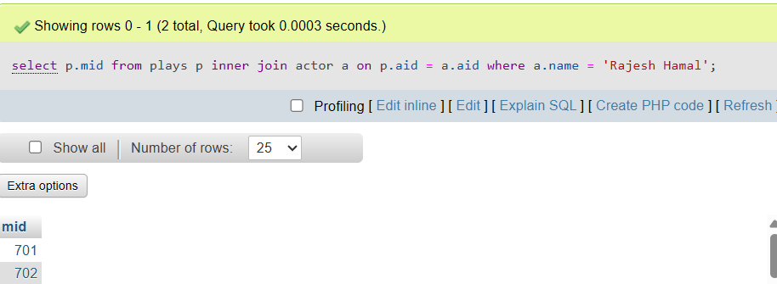

- Find the name of actor and title of the movie whose budget is greater than 3000 .
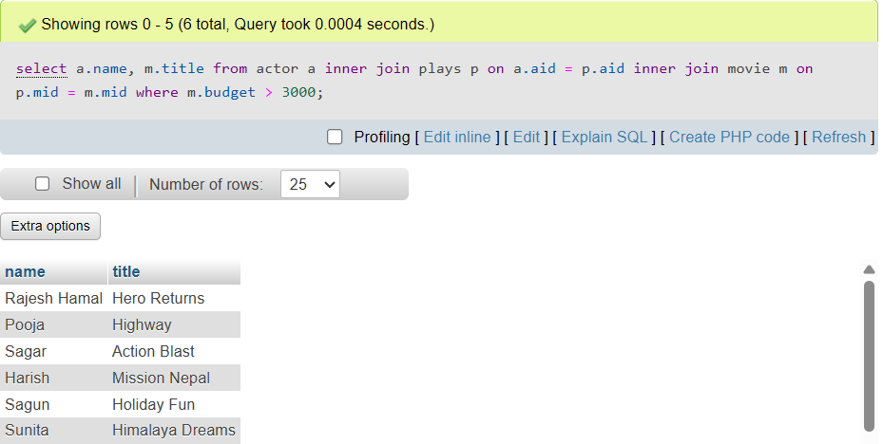

- Display the title of movie for each budget.
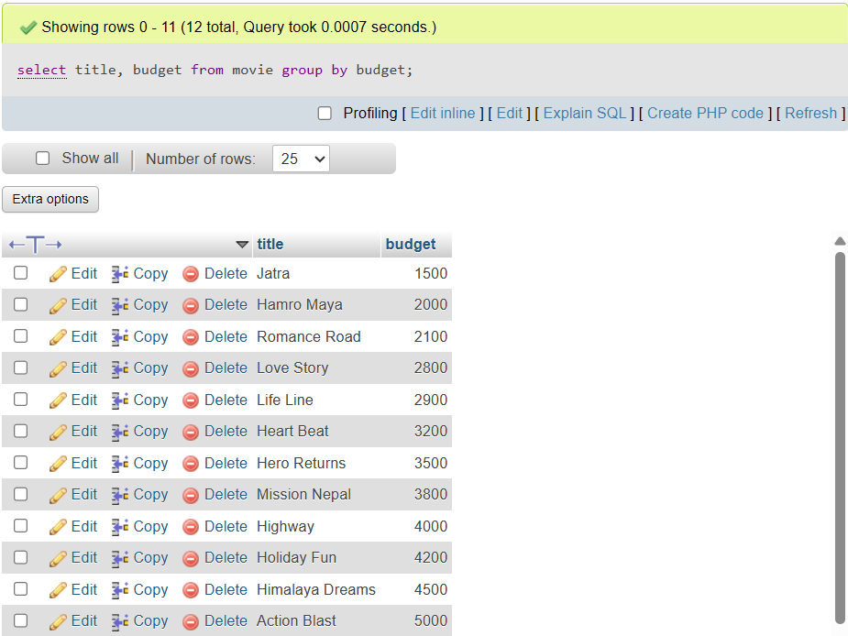

- Find the name and age of actor whose salary is less than that of “Rajesh Hamal”.
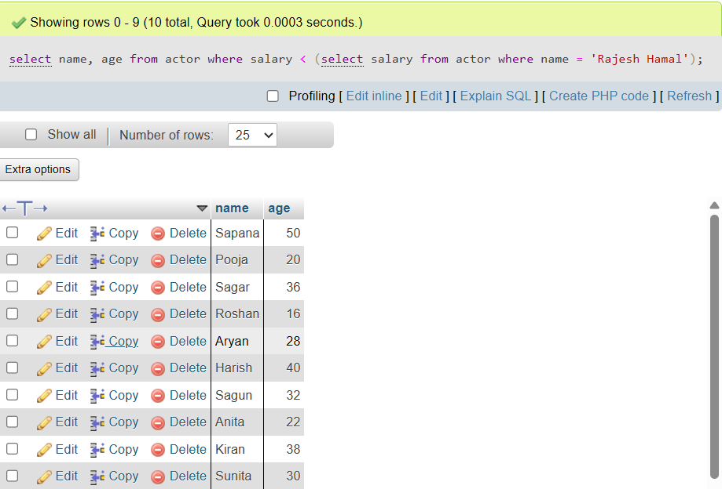

- Retrieve the movie id and movie name in which movie budget is greater than average budget of the movie.
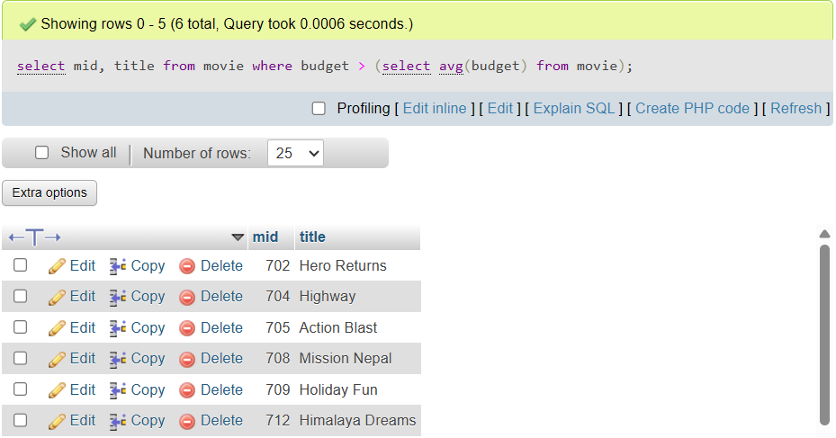
- Display actor id and movie id whose age is greater than 35 and gender is not female.
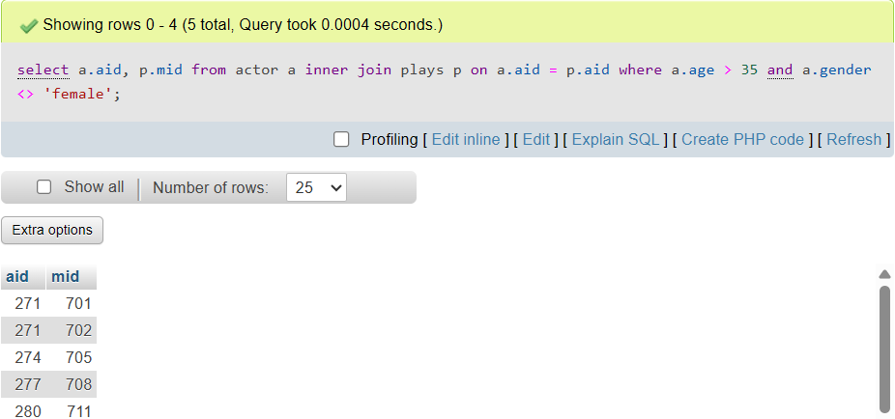

- Calculate the total budget.
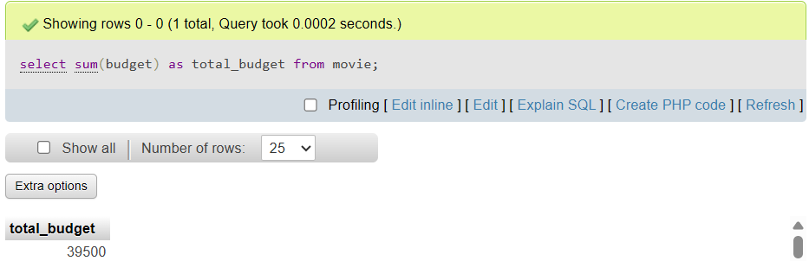

- Arrange the actor name and gender from salary.
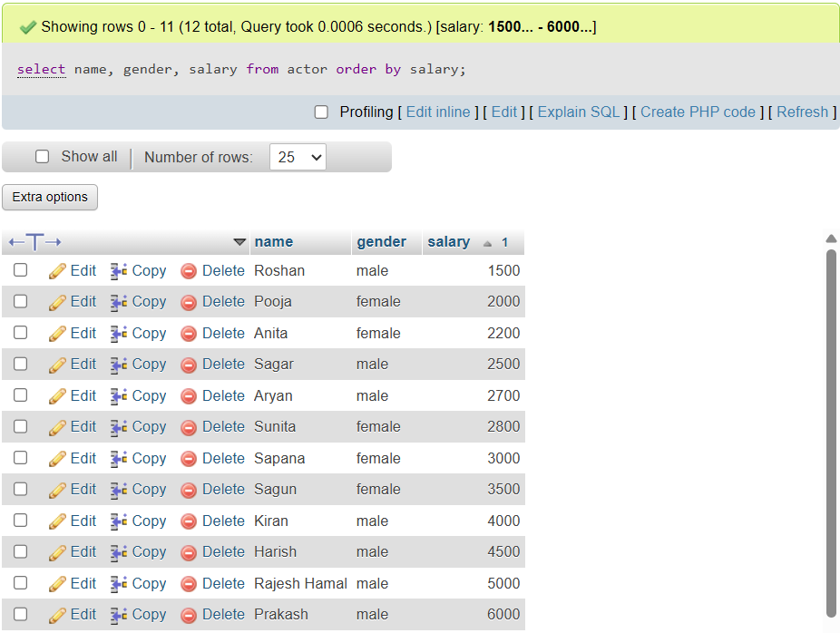

- Display the first record of the movie.
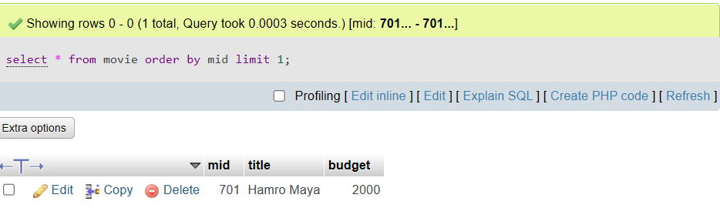
- Display the last record of the actor.
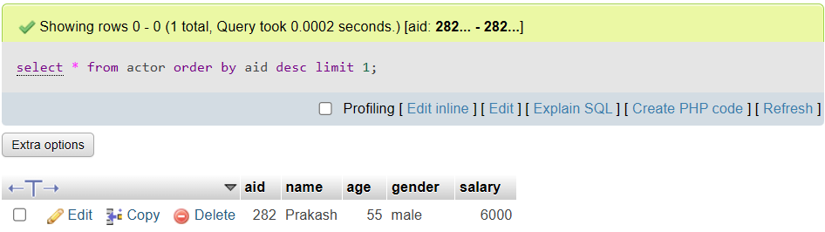
- Display the first five record of the actor.
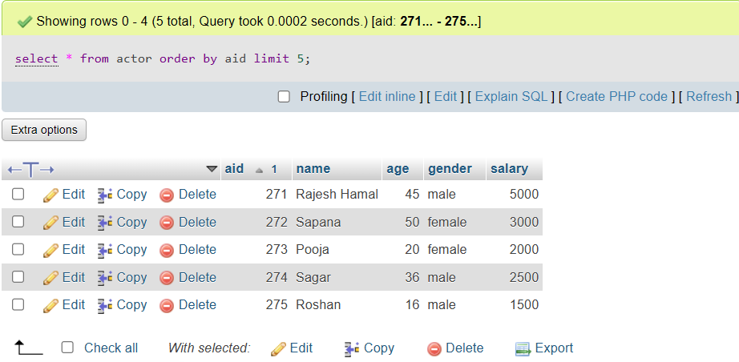

- Display the last 4 record of the actor.
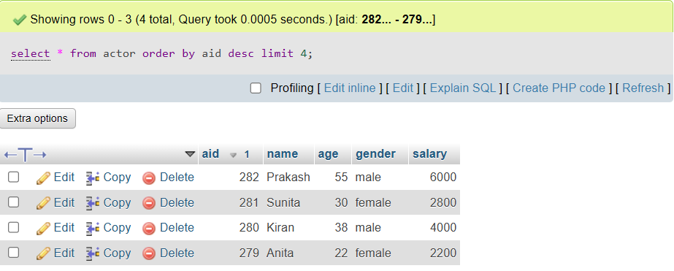

- Display the record of the movie from movie id 3 to 6.
